

CAPSTONE PROJECT REPORT
Report 5 – Software Test Documentation

– Ho Chi Minh City, August 2026 –
Table of Contents
I. Record of Changes 3
II. Testing Documentation 4
1. Scope of Testing 4
1.1 In Scope 4
1.2 Out of Scope 4
2. Test Strategy 4
2.1 Testing Types 4
2.2 Test Levels 5
2.3 Supporting Tools 6
3. Test Plan 7
3.1 Human Resources 7
3.2 Test Environment 7
3.3 Test Milestones 8
4. Test Cases 8
5. Test Reports 8

List of Tables
Table 01. Testing Types
Table 02. Test Levels
Table 03. Supporting Tools
Table 04. Human Resources
Table 05. Test Environment
Table 06. Test Milestones
Table 07. Test Case

List of Figures
Figure 1. Unit Testing Report
Figure 2. Unit Testing Pie Chart

I. Record of Changes
Date | A*  M, D | In charge | Change Description
20/07/26 | A | Huynh Thai Tu | Initial version of the Software Test Documentation. Scope, strategy, plan, and test-result summary aligned to the FE-01–FE-07 feature set and the project's automated test suites (xUnit for the .NET microservices, pytest for the Python AI workers).
09/08/26 | M | Huynh Ngoc Ky | Reviewed document structure, updated table titles, and reformatted the content
14/08/26 | M | Huynh Ngoc Ky | Modified Unit, Integration, System, and Acceptance Test documents.
*A - Added M - Modified D - Deleted

II. Testing Documentation

1. Scope of Testing

1.1 In Scope
Testing will focus on the main functional features and selected non-functional requirements of the WarpTalk system.
The testing scope includes:
- Backend Microservices: Authentication, Workspace, Translation Room, Meeting, Transcript, Billing, Notification, Assistant and Gateway.
- AI Processing Flows: Speech-to-text, translation, text-to-speech, embedding, AI assistant response generation and AI usage-related billing.
- Core Business Flows: User authentication, workspace management, translation room management, meeting participation, transcript management, real-time translation, AI assistant support billing, and notification.
- Data and Messaging Integration: Interactions with service-owned databases, Redis-based messaging, and asynchronous event processing between services and workers.
- Security Validation: Authentication, authorization, role-based access control and access control for workspace, meeting, translation room, transcript and billing data.
- Reliability Validation: Handling invalid requests, service errors, failed background jobs, provider errors, and unavailable dependencies in controlled scenarios.
- System-level Flows: Main end-to-end flows such as real-time transcription, translation, meeting interaction, AI assistant usage, and billing-related usage tracking.

1.2 Out of Scope
The following items are excluded from testing:
- Third-party provider internals, including LiveKit, OpenAI, Stripe, Cartesia and other external AI, voice, payment or communication services.
- Real production payment processing and actual financial settlement.
- Hardware and device-specific behavior, including microphone, speaker, headset, audio driver, browser, operating system and platform-specific issues.
- Production-scale performance testing, including stress, spike, large-scale concurrency, and scalability testing.
- Full AI model quality evaluation, including linguistic accuracy, speech recognition accuracy, translation quality, text-to-speech quality and generated response quality.
- UI/UX aesthetic validation and automated cross-browser or cross-device compatibility testing.
- Network infrastructure, server-level configuration, production monitoring, alerting and observability infrastructure validation.
- Security penetration testing and vulnerability assessment beyond basic authentication, authorization and access-control validation.
Assumptions and Constraints
- PostgreSQL and Redis are assumed to be available during integration testing.
- Required backend, gateway, and AI processing services are assumed to be running in the test environment.
- External providers such as LiveKit, OpenAI, Stripe, and Cartesia are tested through mocks, stubs, test doubles or sandbox environments.
- All test data is synthetic and does not contain real user meeting content, payment information, or production data.
- If required infrastructure or services are unavailable, affected tests are reported as environmental issues rather than product defects.
- Some real-time AI results may vary depending on input audio quality and third-party AI model behavior.
- Some test cases may not be executed if required services, test accounts, external sandboxes, or test infrastructure are unavailable.

2. Test Strategy

2.1 Testing Types

Testing types are grouped into functional testing and non-functional testing. Functional testing verifies what the system does against requirements and business rules. Non-functional testing verifies quality attributes such as security, reliability, performance, maintainability, and environment readiness.
# | Testing Type | Objective | Technique | Completion Criteria
1 | Unit testing | Verify that individual methods, validators, and business rules work correctly in isolation. | Automated unit tests with mocked dependencies and representative valid/invalid input cases. | All planned unit tests pass; critical business rules and validation paths are covered.
2 | Integration testing | Verify that related modules and infrastructure-dependent components work together correctly. | Integration tests for selected API, database, cache, and message-processing flows. | Integrated components exchange data correctly; selected API and persistence flows return expected results.
3 | Functional testing | Validate that application features meet the specified business requirements. | Manual and automated test cases based on expected user actions, inputs, outputs, and system behavior. | Main functional requirements are verified; actual behavior matches expected results.
4 | Authorization testing | Confirm that users can only access actions allowed by their role or permission. | Test cases for authorized and unauthorized access scenarios. | Authorized users can perform allowed actions; unauthorized users are rejected correctly.
5 | Performance testing | Measure whether realtime processing flows meet acceptable latency expectations. | Latency measurement tests for important realtime flows. | Measured latency is within the defined acceptable threshold for key realtime flows.
Category | Focus | Application in WarpTalk
Functional testing | Feature behavior, business rules, validation, API results, and user-visible flows. | Confirms that WarpTalk functions work as specified: authentication, workspace management, room lifecycle, meeting participation, transcript, AI assistant, billing, notification, and related API flows.
Non-functional testing | Quality attributes such as security, reliability, performance, maintainability, compatibility, and data protection. | Confirms that the system meets selected quality expectations. In this report, non-functional coverage focuses on security/access control, reliability/error handling, selected performance-related checks, and environment readiness.
Performance testing | A non-functional test type that measures system behavior under workload. | Measures response time, throughput, concurrency handling, latency, resource usage, and stability. Production-scale stress, spike, large-scale concurrency, and scalability testing remain out of scope unless separate evidence is provided.
Table 01. Testing Types

2.2 Test Levels
The project applies four standard SWT testing levels: Unit Testing, Integration Testing, System Testing, and Acceptance Testing / UAT. Test levels describe where testing is positioned in the development lifecycle; they are separate from testing types, which describe what quality aspect is being tested.
Type of Tests | Test Level
 | Unit | System
Unit testing | X
Integration testing |  | X
Functional testing |  | X
Authorization testing | X
Performance testing |  | X
Test level | Objective | Application in WarpTalk | Evidence
Unit Testing | Verify isolated functions, classes, and service logic with controlled dependencies. | Developer-level tests for backend services and AI workers, using mocks, stubs, or test doubles where appropriate. | Report5_Unit Test.xlsx; xUnit and pytest-based automated tests.
Integration Testing | Verify interaction between modules, services, databases, cache, messaging, and external-provider adapters. | Checks service/database integration, Redis or event-processing assumptions, and selected cross-component flows in a controlled test environment. | Integration milestones and automated/service-level evidence from backend and AI test suites.
System Testing | Verify complete application behavior through end-to-end or API-level flows in an integrated environment. | Covers complete WarpTalk flows such as login, workspace, meeting, translation room, transcript, AI assistant, billing, and notification scenarios. | Report5_Test Report.xlsx and consolidated system/API test execution results.
Acceptance Testing / UAT | Validate that the delivered system satisfies stakeholder expectations and business usage scenarios before final demo or release. | Focuses on user-facing business flows, final demo environment verification, acceptance criteria, and readiness for capstone evaluation. | Final demo environment verification and acceptance testing milestone; UAT checklist or acceptance evidence.
Table 02. Test Levels

2.3 Supporting Tools
Purpose | Tool | Vendor/In-house | Version
.NET automated testing | xUnit | Open source | 2.9.x
.NET mocking / test doubles | Moq / NSubstitute | Open source | 4.x / 5.x
ASP.NET integration testing | WebApplicationFactory + Testcontainers PostgreSQL | Microsoft / Open source | .NET 10 / Testcontainers 4.x
Python automated testing | pytest + pytest-asyncio | Open source | 7.4+ / 0.23+
Local manual/system testing environment | Docker / Docker Compose | Open source | —
Manual API testing | Browser / HTTP client | In-house | —
Table 03. Supporting Tools

3. Test Plan

3.1 Human Resources
Worker/Doer | Role | Specific Responsibilities/Comment
Huynh Thai Tu | Leader / Test coordinator | Coordinate the testing process, assign tasks, monitor progress, prepare the test plan, and consolidate test reports. Also responsible for Auth, Gateway, and general API access tests.
Huynh Ngoc Ky | Developer / Tester | Design and execute tests for Billing and Notification features, including subscription, payment, invoice, usage tracking, and notification delivery scenarios.
Ngo Xuan Hanh Nhi | Developer / Tester | Design and execute tests for Transcript and AI pipeline features, including speech-to-text, translation, text-to-speech, transcript processing, and latency-related checks.
Tran Manh Tuan | Developer / Tester | Design and execute tests for Translation Room, Meeting, and Workspace features, including room lifecycle, participant flow, meeting access, and workspace membership scenarios.
Table 04. Human Resources

3.2 Test Environment
Purpose | Tool | Provider | Version
.NET runtime & SDK | .NET SDK / ASP.NET Runtime | Microsoft | 10.0
Python runtime | CPython | Python.org | 3.11+
Relational database | PostgreSQL | Open source | 16+
Cache & streams | Redis | Open source | 7.x
Message bus | RabbitMQ | Open source | 4.x
Realtime media SFU | LiveKit Cloud / LiveKit Server | LiveKit | Cloud service / 1.13.x
Container runtime | Docker / Docker Compose | Docker | —
Developer OS | Windows | Microsoft | —
Table 05. Test Environment

3.3 Test Milestones
Milestone Task | Start Date | End Date
Prepare test plan, test scope, and test case structure | 01/07/2026 | 06/07/2026
Unit, validation, and integration testing for core modules | 07/07/2026 | 05/08/2026
Functional, authorization, and realtime pipeline testing | 06/08/2026 | 24/08/2026
Regression testing, bug-fix verification, and full-suite consolidation | 25/08/2026 | 02/09/2026
Final demo environment verification and acceptance testing | 03/09/2026 | 05/09/2026
Table 06. Test Milestones

4. Test Cases
The detailed test cases are in the two spreadsheets:
- Unit and component-level test cases: Report5_Unit Test.xlsx
- System/API and UAT-oriented test cases: Report5_Test Report.xlsx
No | Testing Level | File Name
1 | Unit Test | Report5_Unit Test.xls
2 | System Test | Report5_Test Report.xls
Table 07. Test Case

5. Test Reports
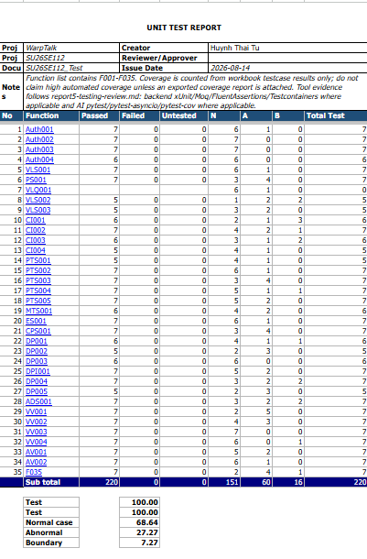
Figure 1. Unit Testing Report 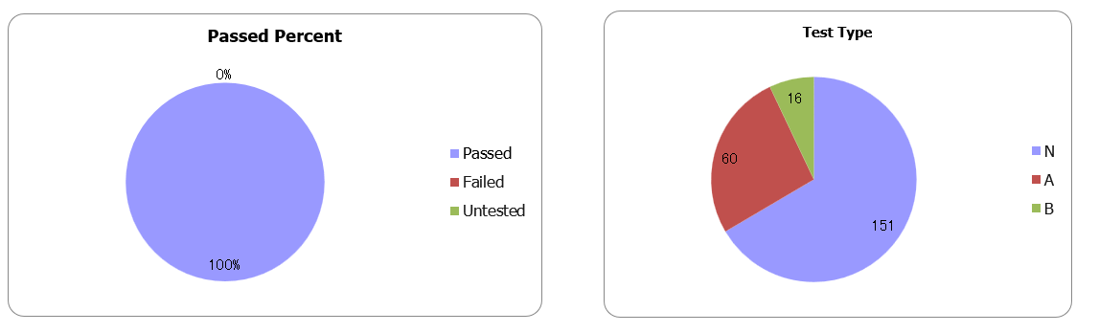
Figure 2. Unit Testing Pie Chart

